Approvals:
Department | Name | Signature | Date
QA | Scott Pletzer
OPS | Michael Stowell
Exec | Nancy Rizzo
IS | Andrew Mason

- Purpose

The purpose of this document is to describe the specifications for the ClearView system calibration process.

- General Requirements

Where appropriate, logic should be contained in try/except blocks and any exceptions should be logged using the standard logging mechanisms.

- Specifications

Requirement #4.1: The calibration process must take 5 warm up images before capturing the 10 images to use in the actual calibration calculation process.
Specification: The automated calibration routine will capture five energized images at the beginning of the process. The images are captured approximately 1 second apart. These five images will not be used in the calibration process itself and are not persisted, the sole intent of generating these images is to warm up the device.

Requirement #4.2: The calibration must be calculated using 10 sample images captured sequentially.

Specification: One the warm up images have been captured, the automated process will then continue to capture ten sequential images. The images are then saved as bitmap files to be used in the analysis process that follows. Each of the images being captured can be seen on the calibration page. The images are captured through the standard image capture algorithm of the system.
Requirement #4.3: The delay between capture should be approximately 2 seconds.

Specification: A delay of approximately one second exists between the capture of each image.

Requirement #4.4: The calibration process will be accessible to all users.

Specification: All user roles (Base User, EPIC Administrator,System Administrator and techadministrator) can all access the calibration function. The function is always available to any user with the exception of when a user is performing a capture or some other system function.

Requirement #4.5: The button to access the calibration process must appear on the main menu.

Specification: The button to access the calibration function appears in the main menu of the application.

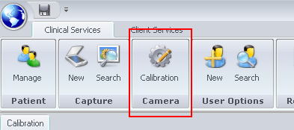
The button is always present once a user has logged in and is easily visible and discernible.

Requirement #4.6: Calibration is required before a scan can be performed under the following circumstances:

- If 24 hours have elapsed since the last calibration process has been performed.

- If more than 4 hours have elapsed since the device was last accessed (aka. a scan was performed).

- If the calibration settings have been changed in any way.

Specification: A routine containing two separate checks is run before any scan can take place. The function “MustCalibrateCamera” which returns a Boolean indicating whether or not a calibration is needed performs the following checks in the following order.

  - First determine if a successful calibration has been run within the past 24 hours. If one has not returned a true value indicating that a calibration must be run.

  - Second, if a successful calibration has been run within the past 24 hours, determine if the device has been accessed within the past 4 hours. If the device has not, return a value of true indicating that the device must be calibrated.

If a true value is returned, logic in the application will inform the user of the need to calibrate and will prevent a scan from being performed until the process is successfully completed.
In addition to the above two checks a third check is performed to verify that the necessary Matlab and bitmap files are present in c:\temp\calib_results.

Requirement #4.7: The date and time of a successful calibration as well as the images associated with the calibration must be stored in the database. No record of an unsuccessful calibration needs to be maintained.

Specification: Upon a successful calibration an entry is placed in the table named 'Calibration', a description of the table is noted below:

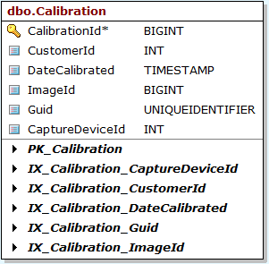
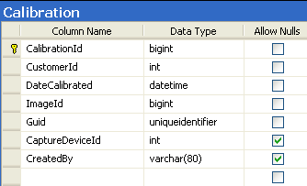
All of the columns in the table are filled with data before the row is created, the column DateCalibrated contains the time and date that the successful calibration was run. The created by column, contains the user that ran the calibration process.

Requirement #4.8: The calibration process should be controlled by a single button available to all users labeled 'Auto Calibration'. Clicking this button should do the following without user input:

- Collect 5 warm-up images

- Collect 10 images to use in the calibration process

- Persist data if successful

Specification: The calibration dialog is shown below; the button to begin the calibration process is noted in the lower right corner of the dialog. Clicking this button begins the following sequence:

- The Auto Calibration button is disabled as well as the Close button.
- Five warm up images are captured.
- Ten calibration images are captured, each one is analyzed at time of capture for pass/fail criteria If any image fails, the process is considered failed and is stopped.

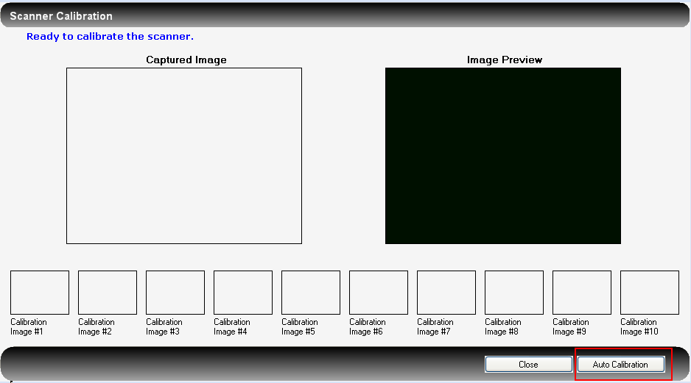
If all of the images pass the calibration check, they are written to the database as a single zip file containing all 20 images.

Requirement #4.9: Present the user with a progress indicator of some sort so they are aware of where they are in the process.

Specification: A progress indicator and progress message are displayed in the upper left corner of the dialog. The messages indicate what step of the process the routine is in.

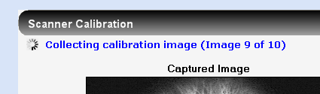

Requirement #4.10: The process must prevent the user from exiting the process once it has begun until a final result has been reached.

Specification: Code has been implemented to cause the close button to become disabled during the calculation process. As soon as the Auto Calibration button is pressed and the process started, all buttons temporarily become disabled. The buttons are re-enabled as soon as the calibration process is complete.

If the user attempts to close the dialog using the X in the upper right corner of the window, the system will check to make sure that the calibration process is not running before allowing the user to close the dialog. If the process is running, the dialog will not be allowed to close.

Requirement #4.11: The administrator and techadministrator users only, should be able to manually load calibration images, bypassing the auto calibration process. Once the user has added the images, a button to perform the calibration calculations should be available.

Specification: If, and only if, the logged in user is administrator, or techadministrator, they can right click on any one of the image placeholders at the bottom of the dialog to cause a file load dialog to appear.

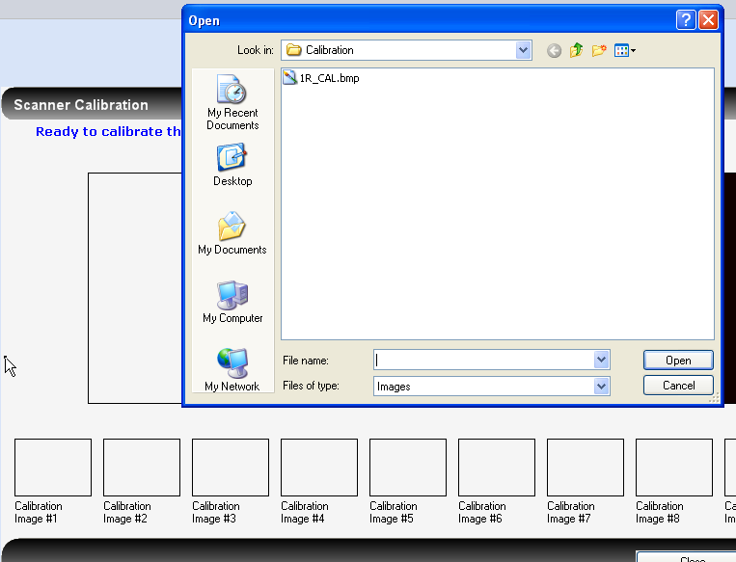
If any other user right clicks in the placeholders, noting will happen. The users can then browse and select a calibration image from the file system. When the image is selected it is added into the selected placeholder.

If an image is manually loaded, the “Auto Calibration” button changes to have a label of “Submit Calibration”. The “Submit Calibration” button will verify that 10 images have been loaded before starting the actual calibration process.

Requirement #4.12: The calibration process should not be accessible unless a scanner is attached to the system. If no scanner is found, a message should be displayed indicating such.

Specification: The system will check for the existence of a scanner prior to displaying any of the dialogs that perform the capture process. The check will be done by verifying that the device can be seen on the USB bus.

If the scanner cannot be detected, a message will be displayed informing the user and the capture process will not be allowed to continue.

In addition two visual indicators will be added to the ClearView application showing the status of both the scanner device and the camera within the scanner. These indicators will appear at the bottom of the application as shown below:

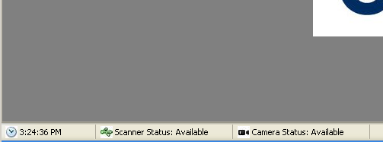
Requirement #4.13: The calibration dialog should allow the 10 captured images to be seen during the calibration process.

Specification: The calibration process displays the ten captured images in thumbnail for at the bottom of the dialog. The full size version of the image can be seen by clicking on the thumbnail.

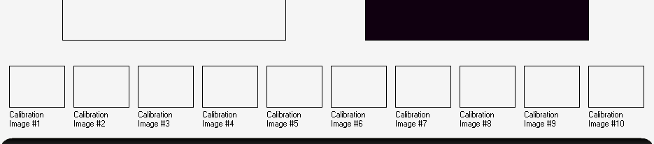

Requirement #4.14: Calibration can be re-run at any time and for as many times as the user desires. Only the last successful calibration will be used for analysis purposes.

Specification: The calibration process is always available on the menu bar. The only time calibration cannot be run is when the user is performing one of the other system functions.

Requirement #4.15: If a calibration process fails, a message should be displayed to the user. In addition the criteria that caused the failure should be placed in the alerts section of the application so they can be reviewed if necessary

Specification: The system will display a message indicating whether or not the image set passed calibration. In the event that the image set does not pass calibration, the system will add a message to the Alerts section of the website indicating what images failed calibration and what order of magnitude they failed by. The decision was made not to display each pixel that failed since this number can sometimes be very large. Rather, the number of pixels that failed in each region is shown.

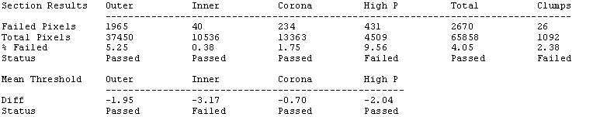

If any of the ten calibration images fail, the calibration set as a whole will be considered to be invalid.

Requirement #4.16: The calibration calculation is defined as follows:

    - The calibration image will be broken down into four distinct regions of interest (the outer noise region, the inner noise region, the corona region and the high plateau region).

    - Each of the areas is then compared to the threshold values for the respected area.

    - If the total count of pixels that fail are equal to or greater than the limit specified for the given area, the image fails.

    - The same process will be performed on all 10 images that have been collected.

    - If none of the 10 images fail, the calibration is considered a success.

Specification: Each of the points in the above requirement is described below.

  - After centering the image, the Matlab routine will segment the image into four distinct regions, the pixels in each region will be evaluated as a collection. The region boundaries were established during engineering study ENG-036.

  - The threshold vaues for the specific regions are then compared to the calculated values for the region.

  - If the calculated values exceed the limits determined in the engineering study, the region is considered failed.

  - All ten images go through exactly the same process. If any one of the images fail the calibration process, the set as a whole is considered failed.

  - If no zone in any of the 10 images fails, the image as a whole is considered valid.

Requirement #4.17: The calibration images and the calibration data should be able to be exported from the ClearView database. The export process will label the images with finger and hand references as part of the filename (e.g., 1R).

Specification: The export process will create two folders in the main export folder called ‘CalibrationImages’ and ‘CalibrationData’.

CalibrationImages will contain 10 .bmp files that are the calibration images that were collected. The naming convention will be {Finger Hand}_Calibration_Image_#{image number}.bmp

Calibrationdata will contain a CSV file with the calibration calculation data, an example of which is shown below:

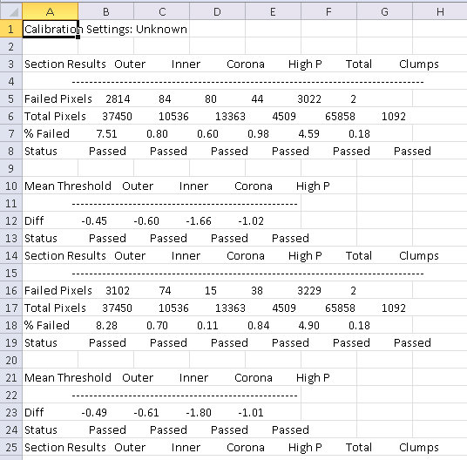

Requirement #4.18: When a successful calibration is obtained, the images and a reference to the calibration are stored in the database. All scans performed after the calibration will reference the calibration. An audit trail will be kept for each image stored in the database consisting of the following tracking points:

    - ID of the user that performed the calibration.
    - Date and time of the calibration down to the minute.

Specification: After a successful calibration, the images are stored in the database for later reference. The database table contains a location for the user that ran the calibration as well as a date and time that the calibration was run, stored in UTC.

Requirement #4.19: Upon a successful calibration, the images should be passed to the Matlab engine to generate the values necessary for the NS coefficient calculation. The NS calculation is specifically described in the Analysis Requirements document.

Specification: Ten Matlab config files are created based on the data in the image. The config files are then used later in the analysis process.

Requirement #4.20: Each calibration image captured should be checked immediately for pass/fail status before grabbing the next image. If the image fails, the process should be immediately stopped.

Specification: The image is immediately analyzed after it is collected. In the case of failure, the process is immediately stopped and the user is informed of the failure. If the user is the administrator user (system user only), all ten (10) images are checked without stopping.

Requirement #4.21: The user should be able to select from the preconfigured calibration setting(s) that were defined.

Specification: When the system is installed, up to four predefined calibration configuration settings can be established. These cannot be modified or configured by any end user of the ClearView system, just the installers and Corporate Administrators.

The settings appear on the calibration dialog and can be selected by the user by clicking on the radio button next to the set to be used.

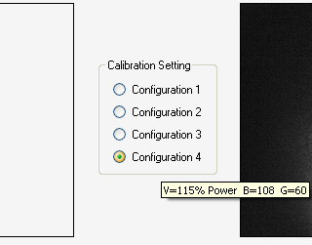

When a radio button is selected, the settings are immediately applied to the device and a calibration process can be attempted. If the calibration is successful, the selected settings are set as the default and used going forward.

The user can mouse-over the configuration name to see the settings releated to that specific configuration.

Requirement #4.22: Up to 4 preconfigured calibration settings should be available for use. The only users that can configure these settings are the administrator or techadministrator. The adjustable settings should be:

    - Brightness
    - Gain
    - Exposure Delay
    - Boost Voltage
    - The Default flag

Specification: In the Settings tab, which is available only to administrators and techadministrator, a new section containing the definition of the four (4) calibration settings is available.

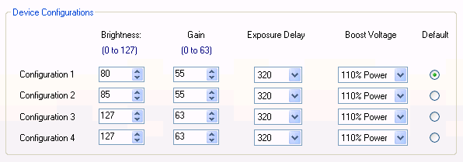

Each data entry point is restricted to a minimum and maximum value that can be selected. Only one (1) default configuration can be selected at a given time.

Requirement #4.23: The user performing a calibration should be able to select from the preconfigured settings before starting the calibration process.

Specification: The user can choose from a set of four (4) radio buttons that represent the four (4) possible configurations.

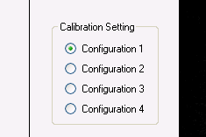

Prior to beginning a calibration process, the user may select from any of the four (4) configuration settings. Floating the mouse over each of the configuration settings will show the values represented by the configuration. If the configuration setting is changed, a successful calibration must be performed using the selected setting before it will be marked as the new default. If no successful calibration is completed, the original default is maintained.

Requirement #4.24: The user should be able to re-run the calibration process in the case where it fails without having to exit and reload the calibration dialog page.

Specification: The user can press the calibration button after a failure to perform the process again. When the button is pressed, all images are cleared and then process is restarted.

Document Revision History
Version Number: | Description of Change: | Date: | Updated by:
000 | Introduction | 5/24/11 | A. Mason
001 | Update for changes to the calibration pass/fail criteria. | 7/8/11 | A. Mason
002 | Update the specifications for requirements:  - Requirement #1- Specify the 2 second delay as a requirement and correct the specification stated to match.  - Requirement #16- Clarify how the number of failed pixels is reported and update the specification to match. Additionally, add the specifications for the local save of the calibration analysis results for each calibration image. | 8/31/11 | A. Mason
003 | Performed a synchronization of the requirements document with this document. Major updates for this revision include the addition of the audit trail requirements (i.e., noting the user id, date and time of calibration image collection) and a modification to the file naming system to facilitate reload of images by EPIC Administrators. | 3/5/12 | A. Mason
004 | Aligned specifications with requirements document. | 7/18/12 | A. Mason
005 | Modified specification to match the requirements added with respect to the new calibration process. | 10/23/12 | A. Mason

